The Uber Lite has two client-side applications, one is for the rider and one is for the driver.

The functionalities in these two applications are different, but they have a lot of commonness. They both have the login part and registration part. Though the information a user need to fill to register a rider account are not exactly the same as to register a driver account, they are quite similar. After login, both these applications will display a map and all operations are based on the map. Because of many commonness these two applications may share in their user interface, we decide to make the style of user interface to be consistent between two. It’s also easier to implement and maintain.

The rider application and driver application uses a design language called Material Design. It is a UI design language developed by Google. The Android system and many applications especially mobile application are using Material Design currently. The wide use of

Material Design proved the excellence of it. Besides, following this design language to design the rider and driver application would decline the probability of making user feels uncomfortable when using them, because they have already used to it.?? Your own sentences or ??

It would take a lot of time developing our own UI components which implement Material Design. Therefore, two React Native components packages are included in the applications -- react-native-material-design and react-native-material-kit. These packages provide a set of React Native components which implement Material Design. Though using these components reduced lots of work, we still need to focus on the layout, shape, animation, color, user interaction and so on.

We want to make it simple for user to use so that every new user can use these apps smoothly. After log into rider application, a map takes the whole screen shows where you are. There is a marker with the label “Get on at here” so that the rider can simple click on the map to set the location to get on a car. The marker is initialized at the center of the screen so the rider can change the location by drag the map. If the start place is too far or the rider cannot recognize it on the map, he/she can also enter the start place manually in the input box. There is nothing else displayed at this step, just a map, a mark and an input box. After entering the start place, another input box will be displayed to ask user to enter the destination. Both these two input boxes have an auto-complete function so that the rider just need to enter a rough place name and select the exact place he/she want. ~~Next, the rest things which are required before sending a riding request will be displayed.~~ After the start and destination locations have been entered, the rider can select types of vehicle, then the estimated price is shown so that the rider can know the general price of these trip and determine whether to send this request.

In driver application, all riding requests within 10 miles posted around him/her will be shown above the map so that the driver can easily click it to accept a ridging request.

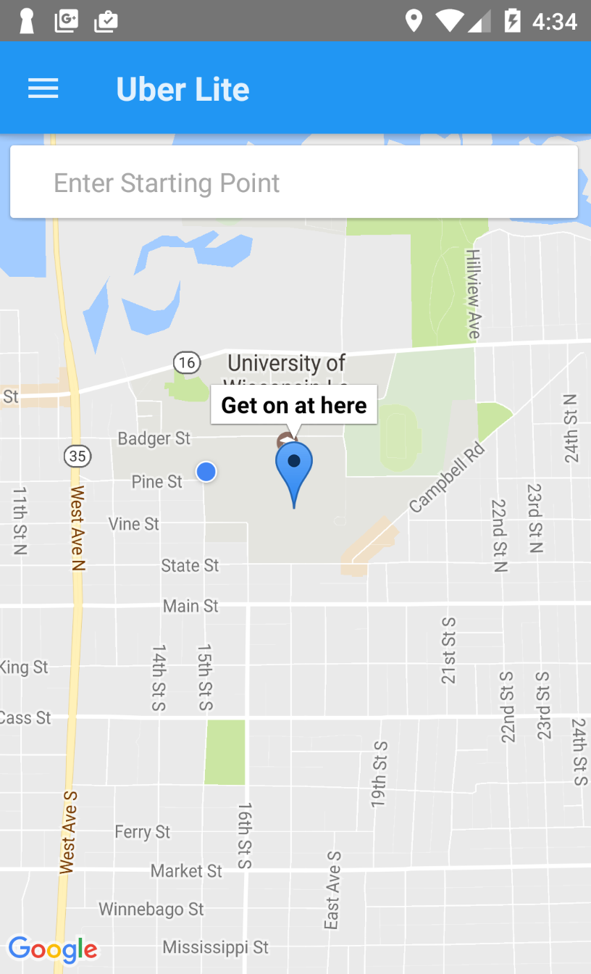 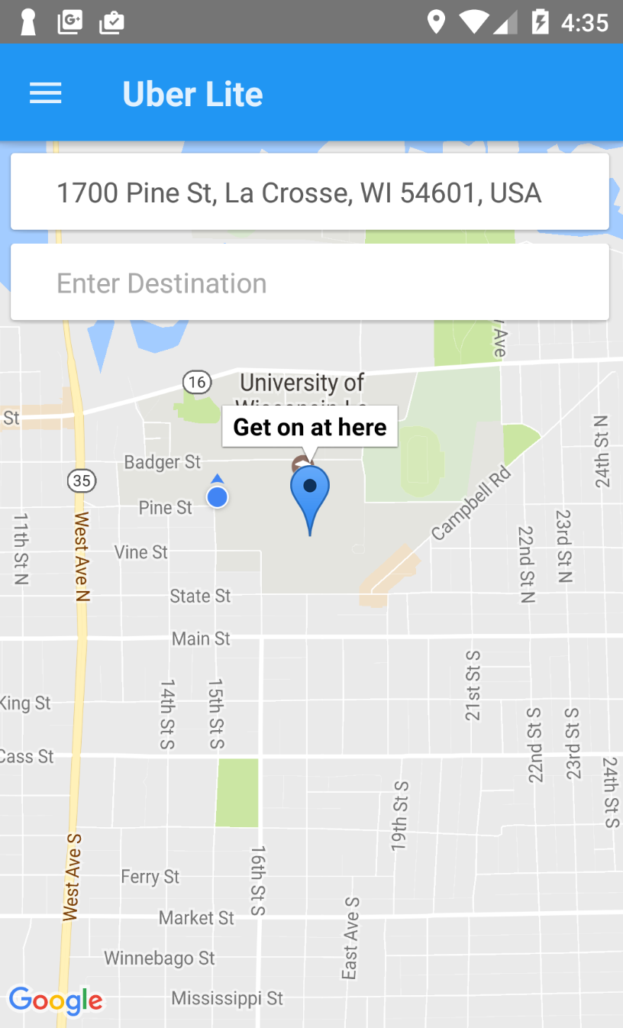

Rider App -- Select Start Point Rider App -- Select Destination

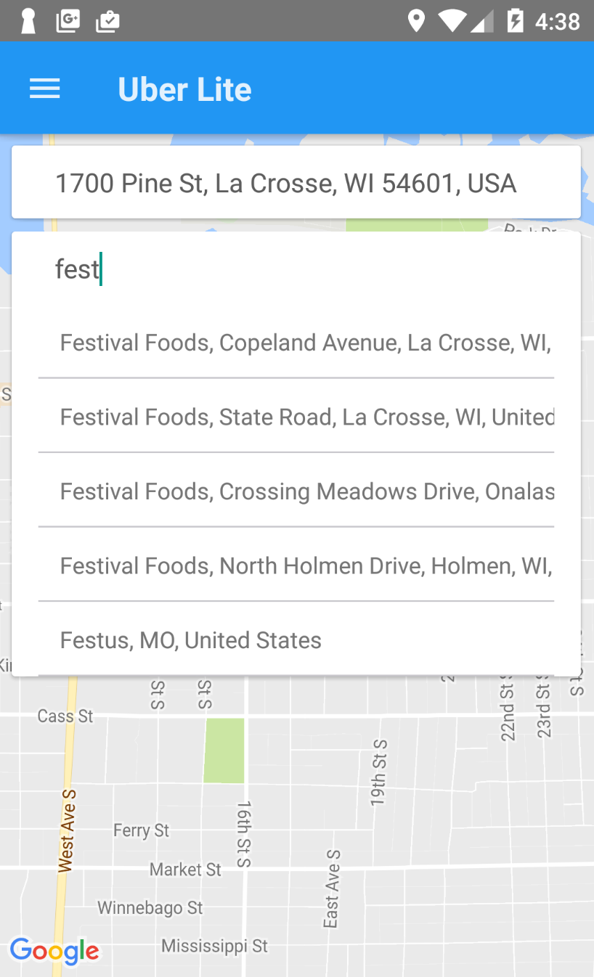 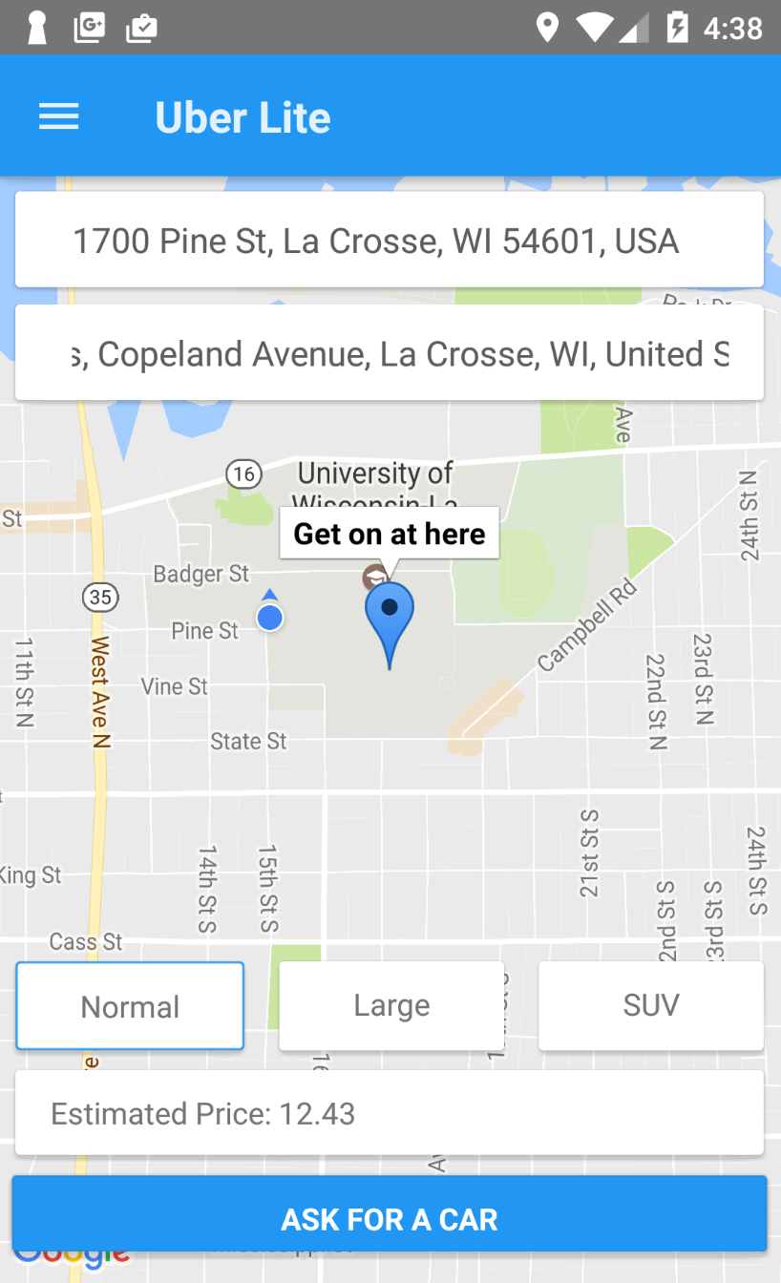

Rider App -- Select Start Point Rider App -- Select Destination

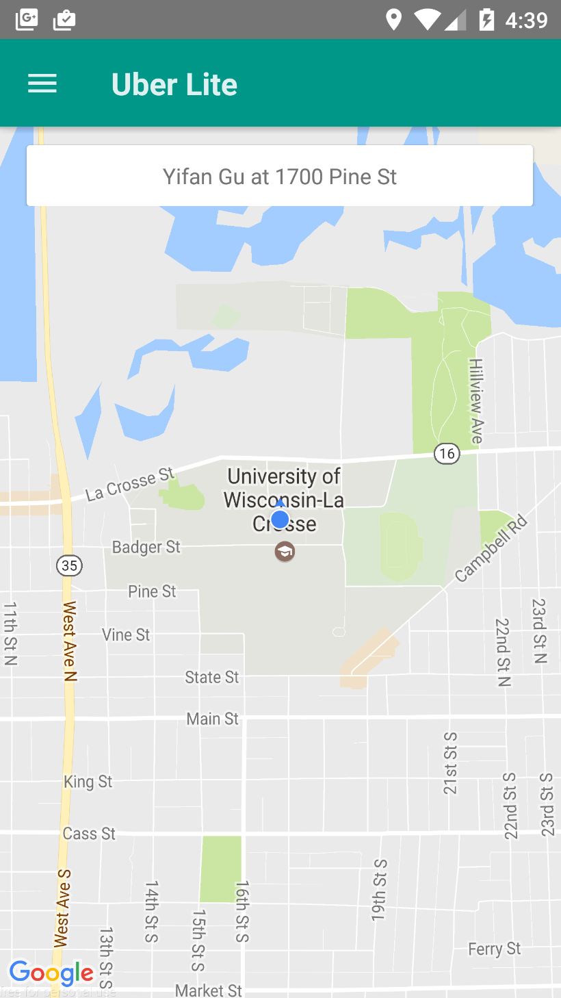

Driver App – The request showing on the top of the map